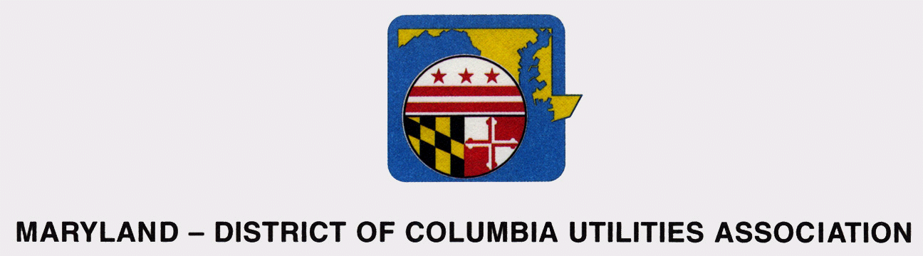

88th Annual Fall Conference
September 12 – 14, 2012

“Living in a SMART World”
____________________________________________________________________________

Wednesday, September 12

10:00 a.m. – Noon Board Members and Committee Chairs Meeting
Schooner A-B

12:30 p.m. Golf Tournament – Shotgun
Steve Miller, Coordinator (Lunch on your own)

2:30 P.M. Tennis Tournament
Mike VonSteuben, Coordinator

6:00 p.m. – 8:00 p.m. Networking Reception
Rivers Edge

Thursday, September 13

7:15 a.m. Registration Opens
Choptank Foyer

7:15 a.m. – 8:00 a.m. Breakfast Buffet
Choptank Foyer

8:00 a.m. – 8:15 a.m. Welcome, Annual Meeting and Election of Officers
John Allen, President
Choptank Ballroom

8:15 a.m. – 8:30 a.m. Legislating in a Smart World
Honorable Michael Busch
Speaker of Maryland House of Delegates

8:30 a.m. – 9:00 a.m. Keynote Speaker
Nick Sinai, Senior Advisor
White House Office of Science and Technology Policy

Maryland – District of Columbia Utilities Association 88th Annual Fall Conference

Living in a SMART World
_____________________________________________________________________________

Thursday, September 13 (Continued)

9:00 a.m. – 10:30 a.m. Get SMART – Benefits, Opportunities, Challenges of
SMART Technology
Moderator - Ernest Jolly, DC Water

Todd Arnold, Managing Principal
Smart Customer Insights

Brian Sloboda, Senior Program Manager
National Rural Electric Cooperative Association

Charles Kiely, Assistant General Manager, Customer
Care and Operations
DC Water

10:30 a.m. – 10:45 a.m. Coffee Break

10:45 a.m. – 12:15 p.m.. SMART Customer Relationships – Intelligent Interfaces
Moderator - Laura Swisher, Washington
Suburban Sanitary Commission

Judith Schwartz, President, To the Point

Shana Glickfield, Partner, Beekeeper Group

Renee Whitener, Director - Public Relations
Blue Ridge Electric Membership Corporation

Todd Arnold, Managing Principal
Smart Customer Insights

12:15 p.m. – 1:30 p.m. Lunch

1:30 p.m. – 3:00 p.m. Security for a SMART Time
Moderator – Shirley Bardes Hasson, Columbia
Gas of Maryland, Inc.

Dr. William Maconachy, Capitol College

Matthew Scholl, Deputy Director, NIST
Cyber Security for Excellence

Daniel A. Gray, Supervisory Special Agent
Federal Bureau of Investigation

Maryland – District of Columbia Utilities Association 88th Annual Fall Conference

Living in a SMART World
_____________________________________________________________________________

3:00: p.m. – 3:15 p.m. Coffee Break

3:15 p.m. – 4:30 p.m. Driving in a SMART Way
Moderator – Wayne Harbaugh, Baltimore Gas
and Electric

Fred Hoover, Director of Clean Energy
Maryland Energy Administration

Dr. Katherine Clay, Executive Director,
Drive Natural Gas Initiative,
American Gas Association

Tracy Woodard, Director of Government Relations
Nissan

Matthew Forman, Senior Manager
Regulatory Affairs, Chrysler Group LLC

Electric vehicles will be on display.
6:15 p.m. President’s Reception
Regatta Pavilion
7:00 p.m. Crab Feast
Regatta Pavilion
Friday, September 14

7:15 a.m. – 8:10 a.m. Breakfast Buffet
Choptank Foyer

8:00 a.m. – 8:10 a.m. Opening Remarks
Bob Behlke, President

8:10 a.m. – 8:30 am. Association Committee Updates
Arrangements Committee, Lisa Wothers
Choptank Electric Cooperative
Environmental Committee, Steve Fuchsluger
Baltimore Gas and Electric
DC Legislative Committee, Donna Cooper, Pepco
MD Legislative Committee, Robert Glidewell
Washington Gas
Accident Prevention Committee, Jack Ellison
Washington Gas
Operations, Ken Capps
Southern Maryland Electric Cooperative

Maryland – District of Columbia Utilities Association 88th Annual Fall Conference

Living in a SMART World
_____________________________________________________________________________

Friday, September 14 (continued)

8:30 a.m. –9:30 a.m. Legislative/Regulatory Panel
Moderator – Donna Cooper, Pepco

Honorable Betty Ann Kane, Chair
Public Service Commission of the
District of Columbia

Calvin Timmerman
Assistant Executive Director
Maryland Public Service Commission

Honorable Yvette Alexander , Chair
Committee on Public Services and Consumer Affairs
Council of the District of Columbia

Honorable Thomas “Mac” Middleton, Chair
Finance Committee, Maryland Senate

Honorable Dereck Davis, Chair
Economic Matters Committee,
Maryland House of Delegates

9:30 a.m. – 9:45 a.m. Coffee Break

9:45 a.m. – 11:00 a.m. Executive Officer Panel
Moderator – Steven Jumper, Washington Gas

Adrian Chapman, President and COO
WGL Holdings, Inc. and Washington Gas

Thomas Graham, President
Pepco Region

Christopher Carew, Chief of Staff
Office of the General Manager, DC Water

Tony Lewis, Vice President
Verizon Mid-Atlantic Region

11:00 a.m. Closing Remarks
Bob Behlke, President

